**PostMan Documentation**

**URL:**

<https://documenter.getpostman.com/view/36384047/2sA3kRHP6Q>

**Screenshot:**

**For ‘/’ endpoints:**

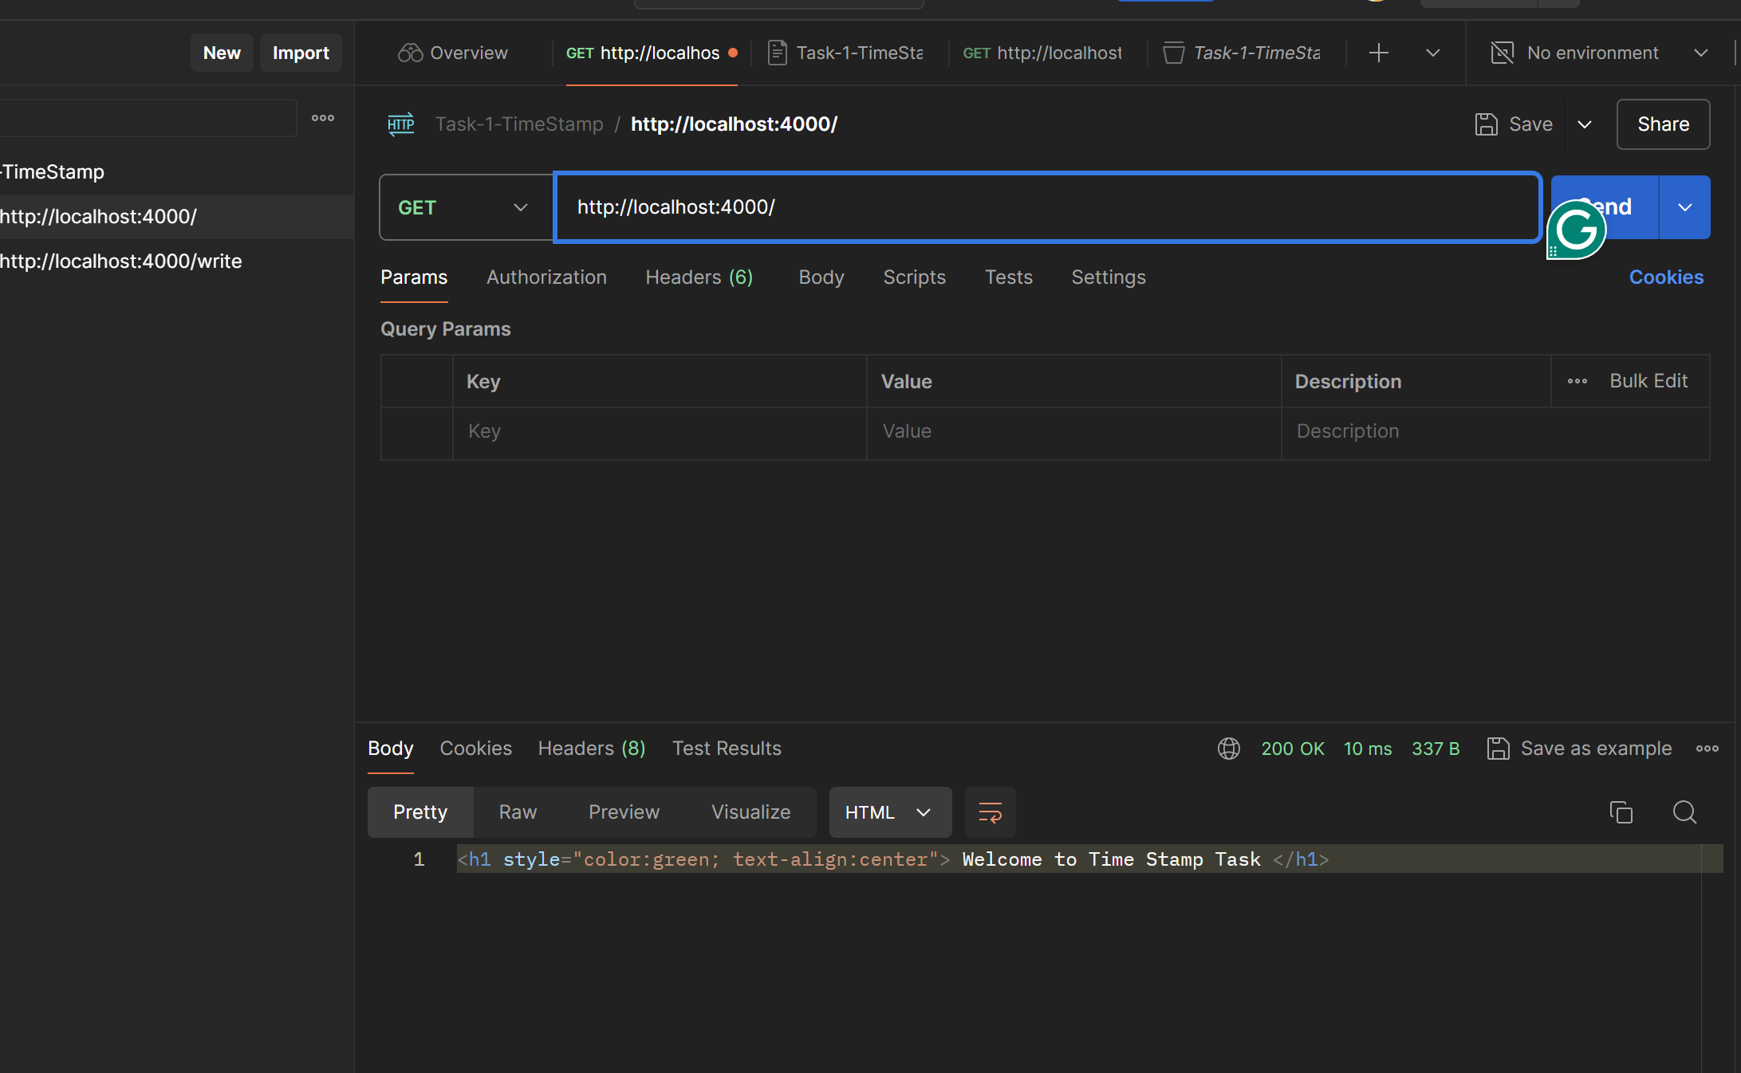

**For ‘/write’ endpoints:**

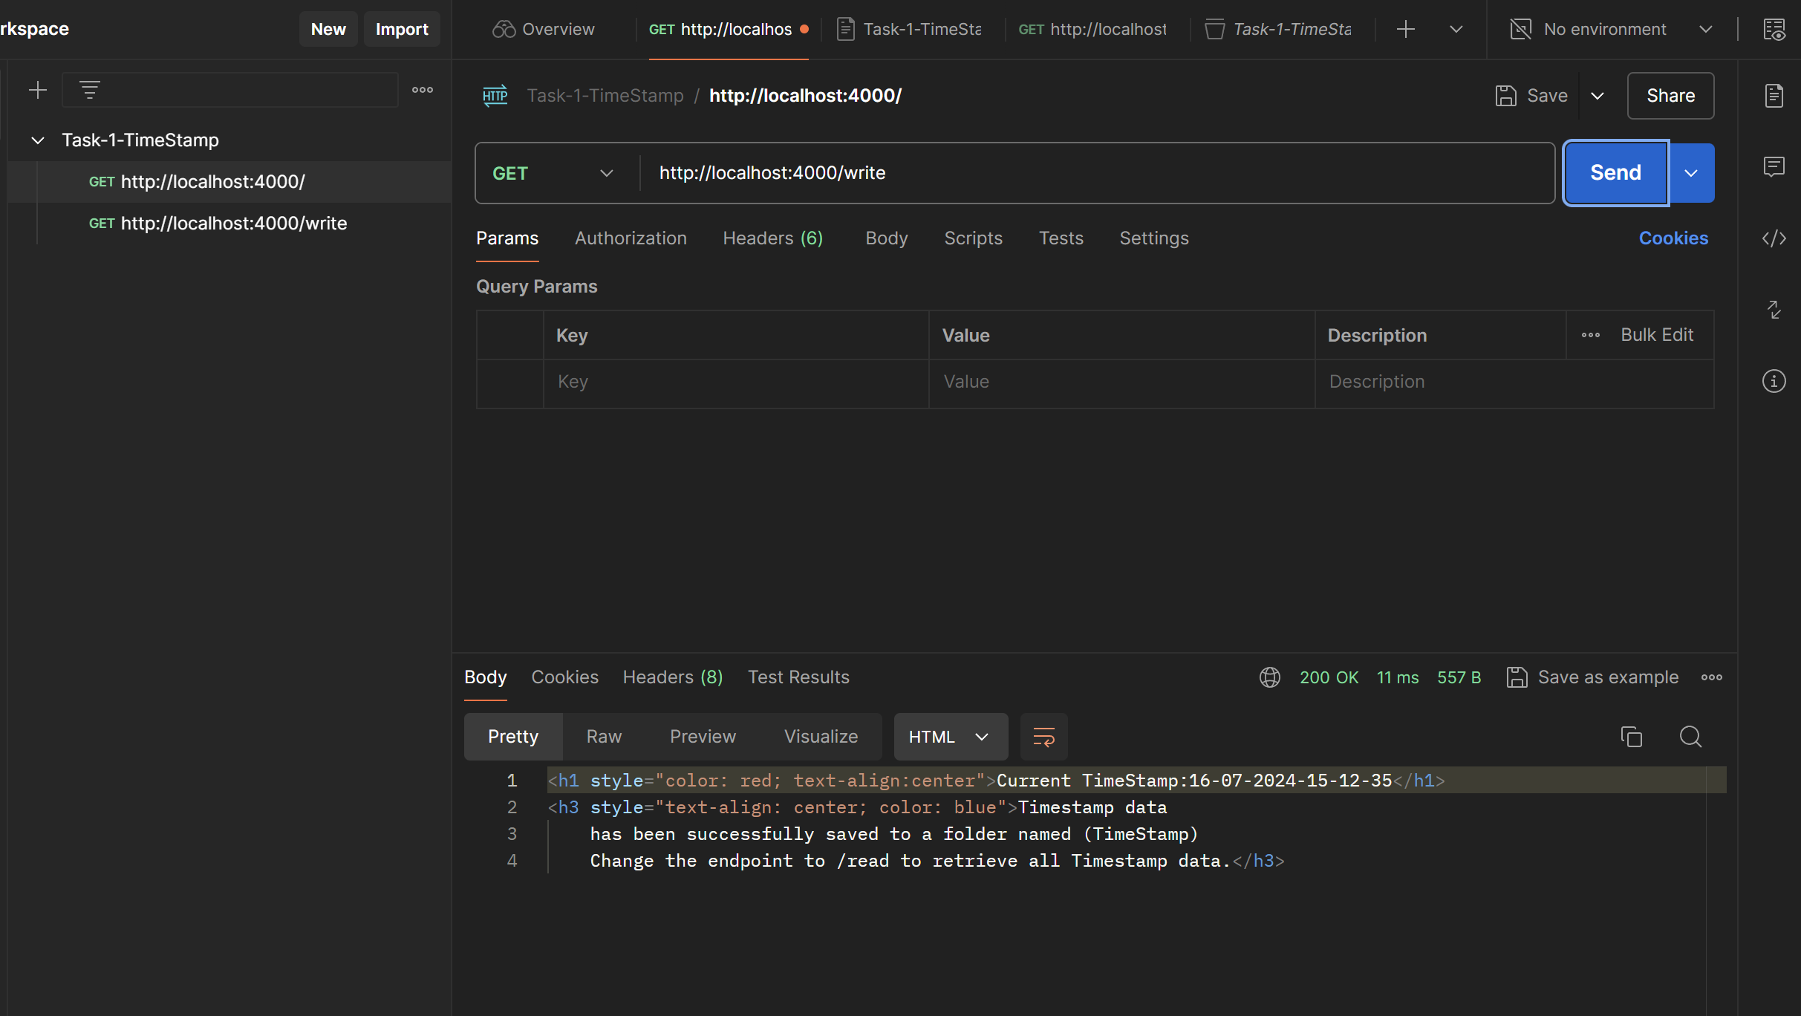

**For ‘/read’ endpoints:**

